**Experiment 8:** Create a Virtual Hard Disk and allocate the storage using VM ware Workstation.

Step 1: Open New File.

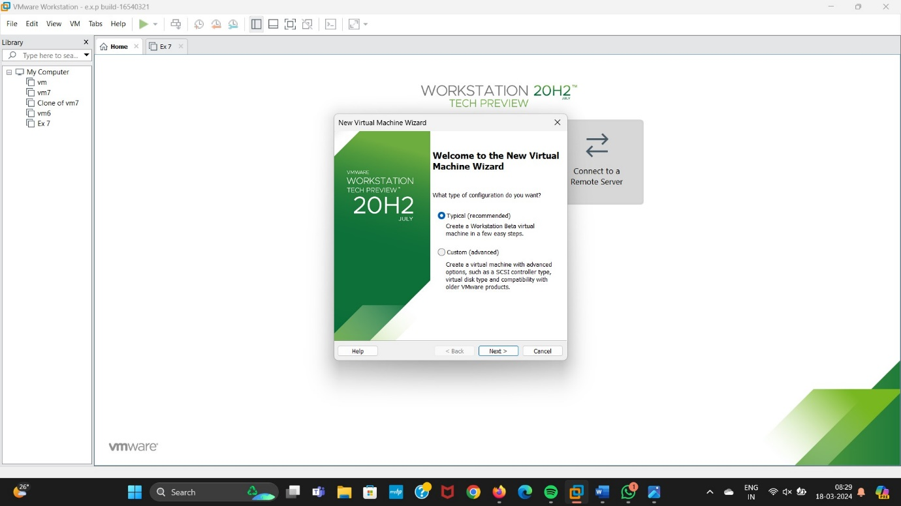

Step 2: Selecting I will install the Operating System Later.

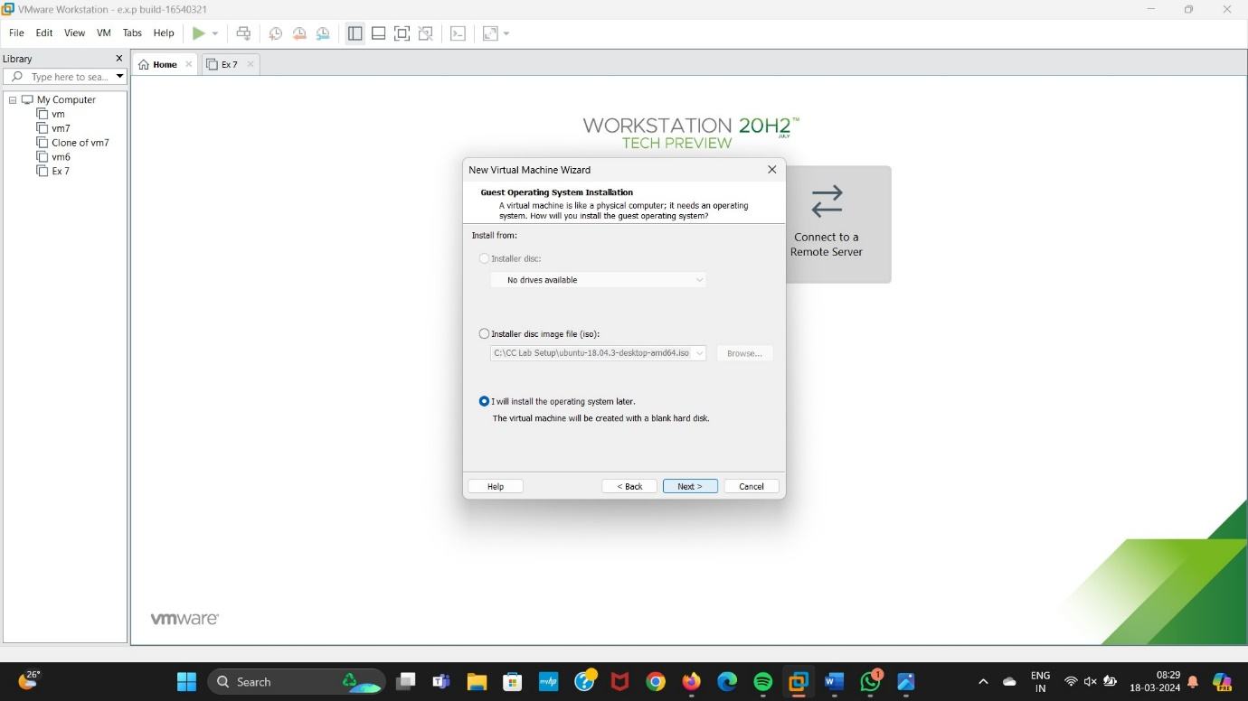

Step 3: Selecting any operating System.

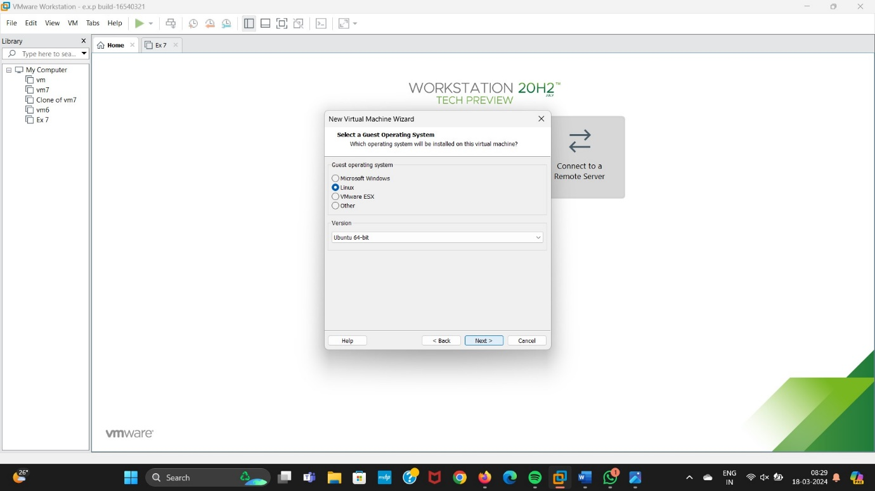

Step 4: Creating a Name for Virtual Machine.

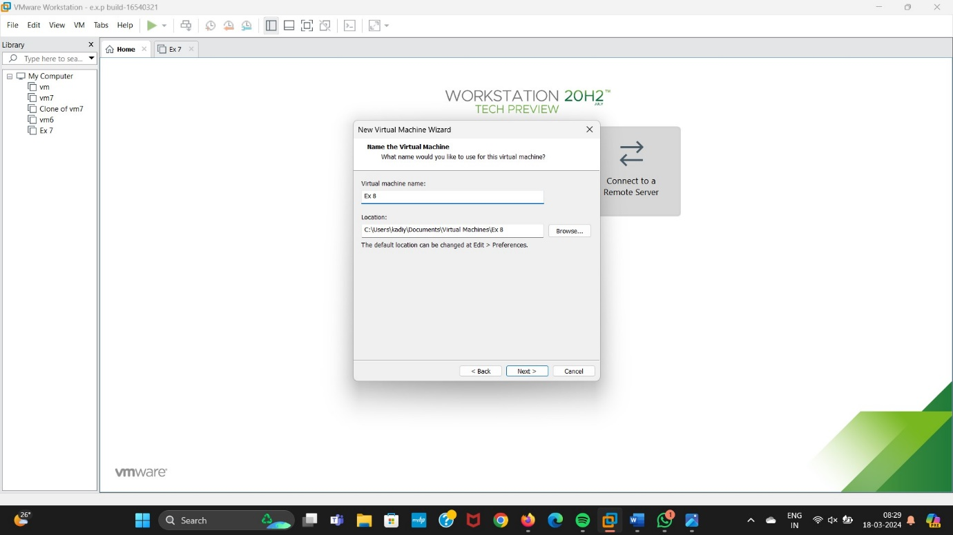

Step 5: Selecting Single file Option.

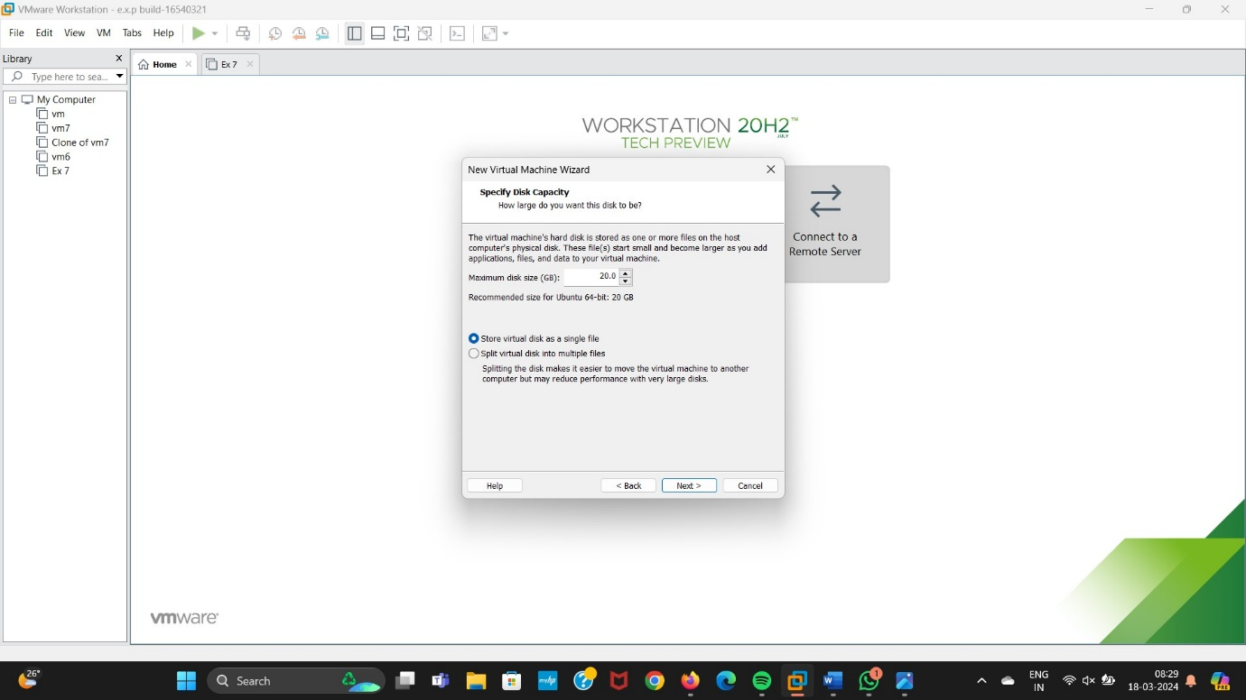

Step 6: Click On Finish Button.

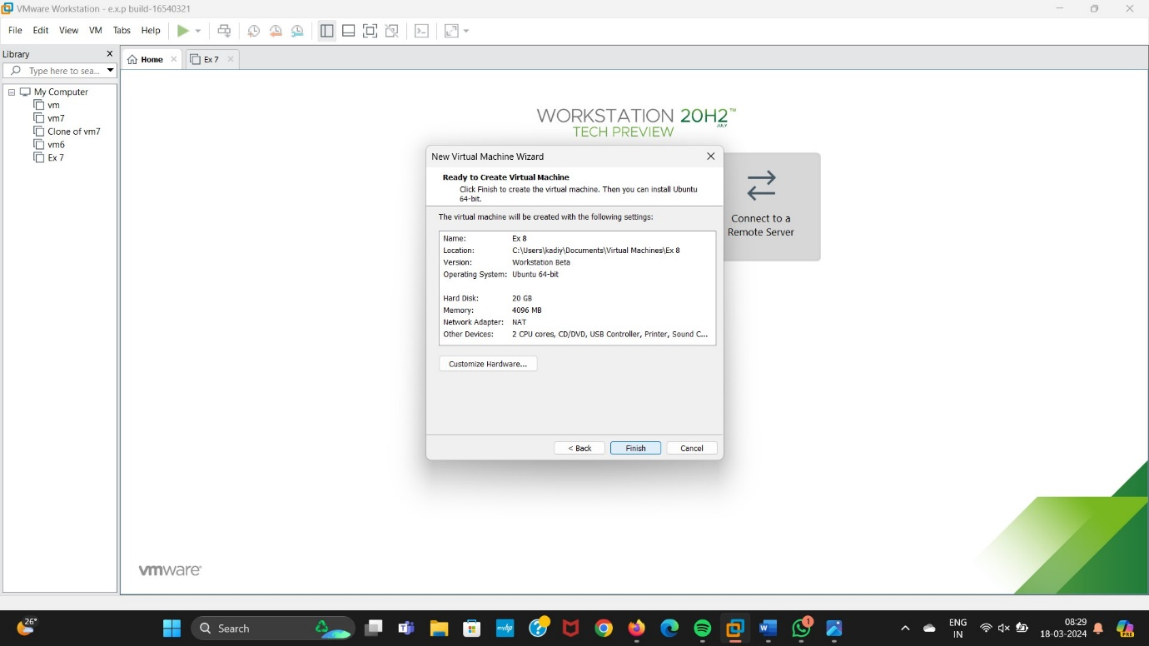

Step 7: Double click on Hard Disk.

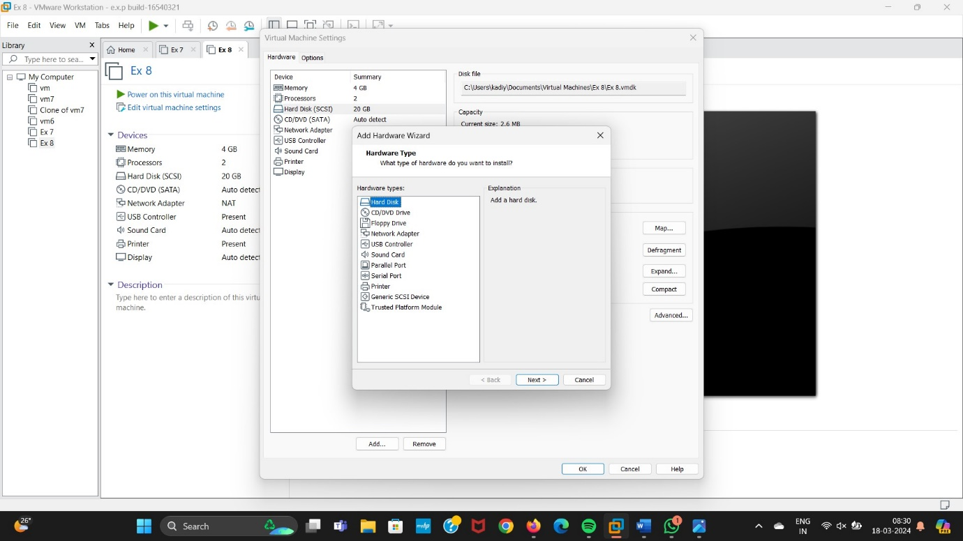

Step 8: Select SCSI Option.

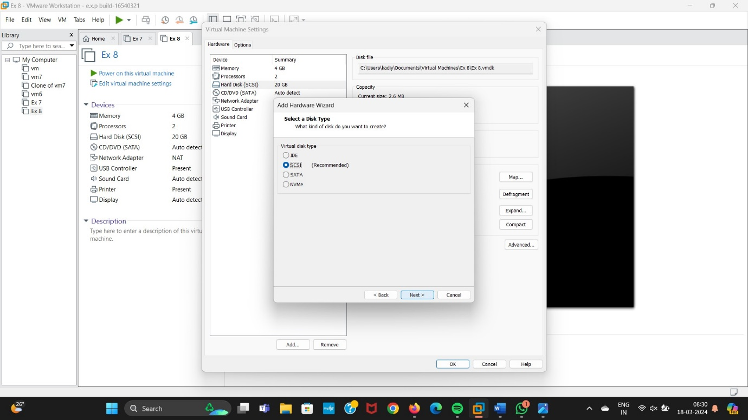

Step 9: Click on Create a New Virtual Disk.

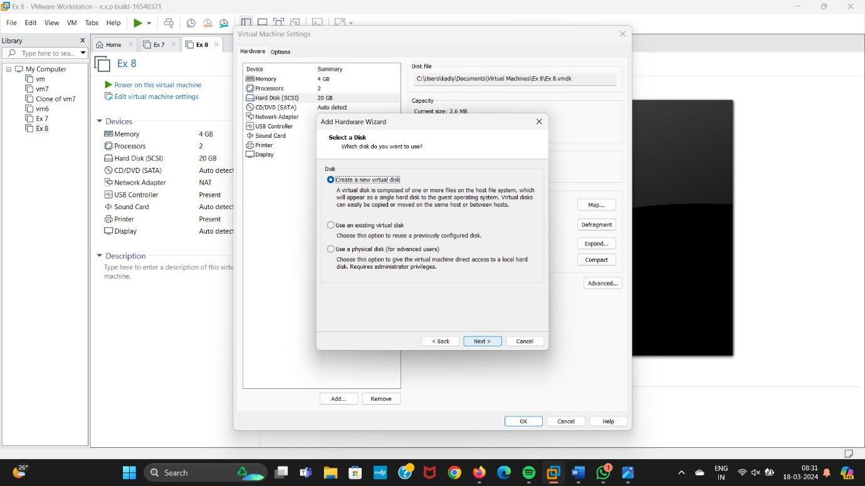

Step 10: Select Single File Option.

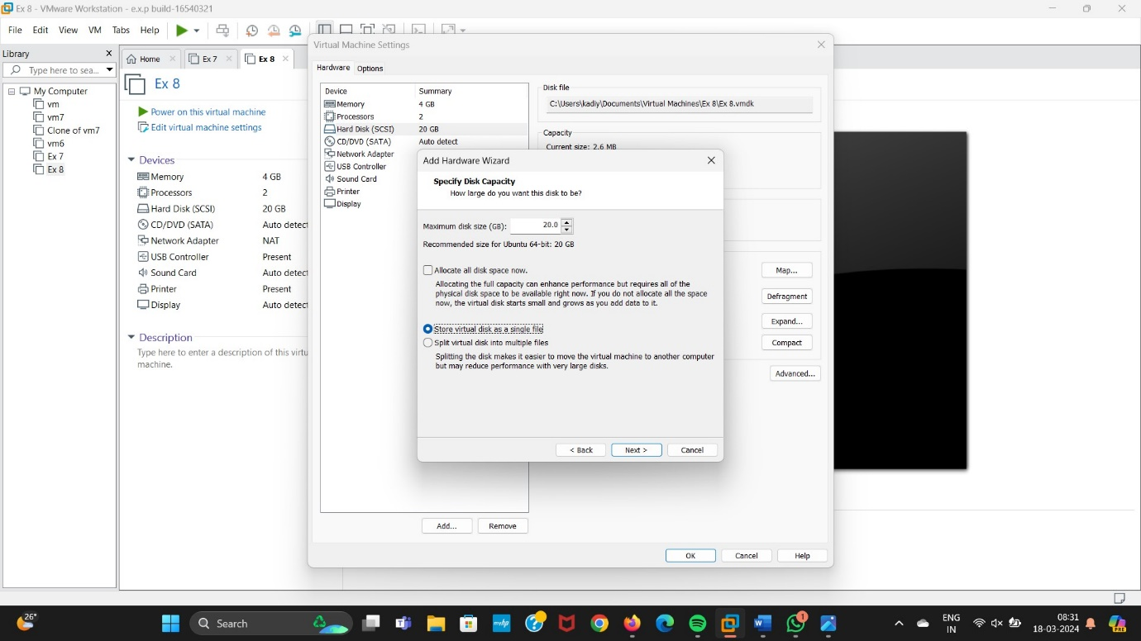

Step 11: Click on Finish Button.

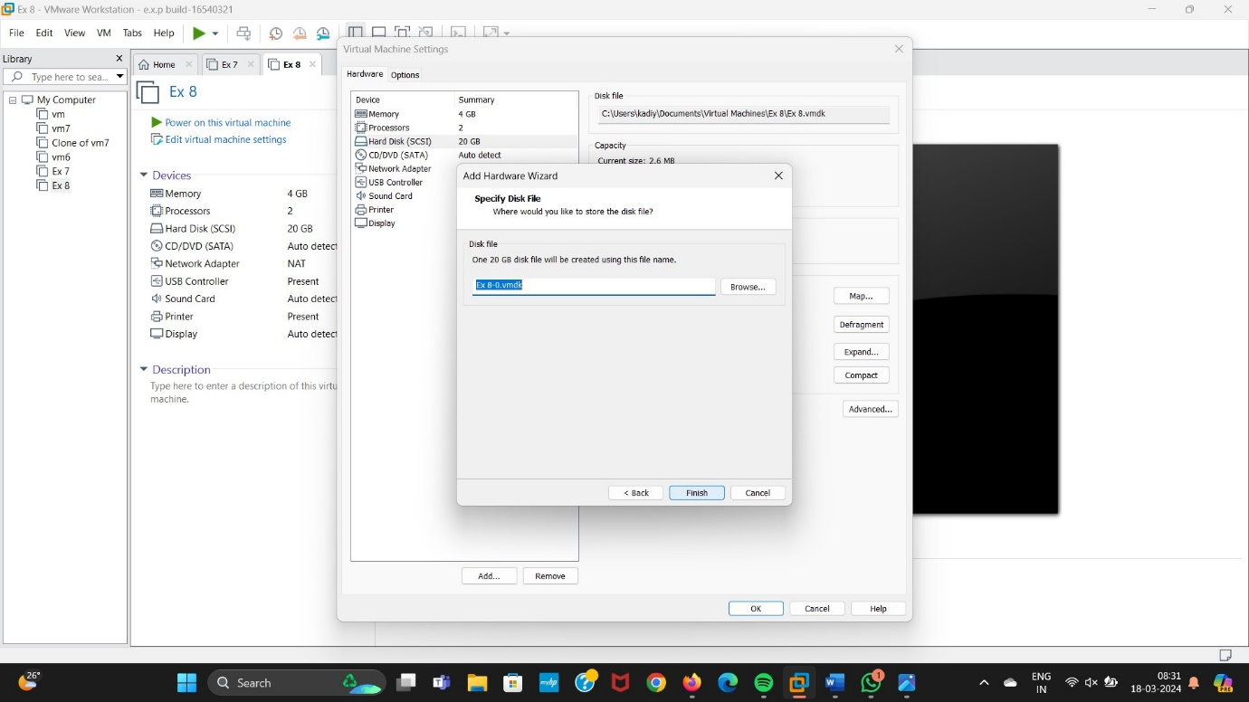

Step 12: Final Output.

